UFO Sightings trends dashboard

Overview

The UFO Sightings trends dashboard provides an overview of different UFO sightings from 1963 to 2018. The dashboard focuses on shape-type distribution in different countries, as well as cities by the duration of the sightings. 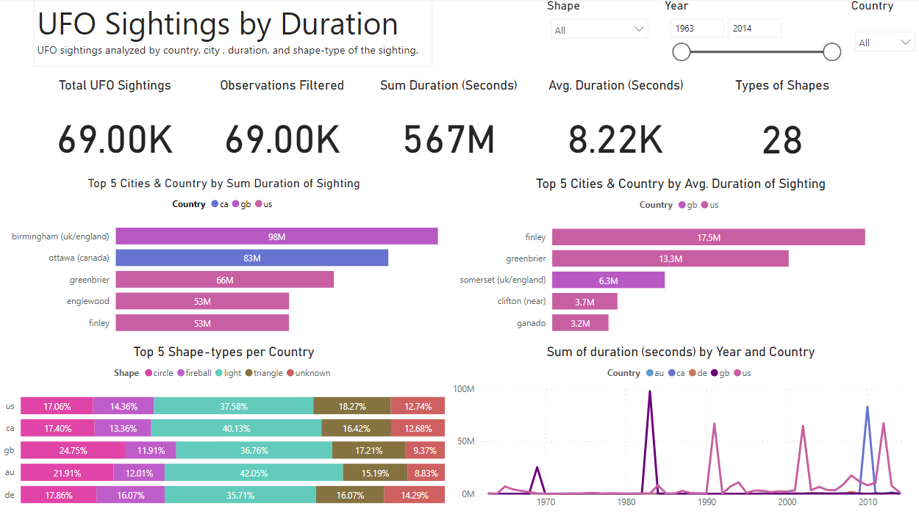

Business Questions

The UFO Sightings dashboard answers the following questions:

* How many total UFO sightings have been recorded?
* Which city has the longest total duration of sightings?
* Which city has the most average duration of sightings?
* What are the most common shape-types per country?

Shape, Year, and Country filters provide more detailed information.

Data Source

Data obtained from Maven Analytics:

<https://raw.githubusercontent.com/bencearato/data/master/ufo_sightings_scrubbed.csv>

Each observation in the UFO Sightings dataset represents a UFO sighting. The following categories are included in the dataset:

* Datetime: this represents the time when the sighting was witnessed.
* City, state, and country: the approximate location where the sighting was witnessed.
* Shape: the shape description of the sighting.
* Duration (seconds), duration (hours/min): the duration the UFO was witnessed.
* Empty values were removed from the data set, unless they were empty in the state category since the states only apply to the United States. Observations with empty cells from the ‘shapes’ and ‘city’ categories were removed entirely.

Dashboard Layout

The UFO Sightings dashboard contain 3 primary areas, in the following vertical order:

* Header (title and subtitle)
* KPI and slicer area
* Chart area (four charts included)

Charts

* ***Top 5 Cities by Sum Duration of Sighting***: A stacked bar chart visualizing the total sum number of seconds of the observations. This shows which cities have had the most sightings by duration.
* ***Top 5 Cities by Avg. Duration of Sighting:*** A stacked bar chart that shows the top average duration of sighting per city. This represents which cities tend to have the longest individual sightings.
* ***Top 5 Shape-types per Country:***  A 100% stacked bar chart displaying the percentage of shape types identified per country.
* ***Sum of duration (seconds) by Year and Country:*** A line chart showing the sum duration of sightings per country on a timeline.

KPIs

* ***Total UFO Sightings:*** The number of UFO sightings, calculated by the total count of datetime, as IDs were not made available in this dataset.
* ***Observations Filtered:*** Total number of UFO sightings under the set filter conditions, calculated by the total count of datetime.
* ***Sum Duration (Seconds):*** Total duration in seconds of UFO sightings, calculated by the sum of duration (seconds) data column.
* ***Avg. Duration (Seconds):*** Average duration in seconds of UFO sightings, calculated by the average of duration (seconds).
* ***Type of Shapes:*** Displays the total number of shape-types observed, calculated by the distinct count of shapes.

Slicers

* ***Shape:*** Drop down slicer with a search bar for all types of shapes observed.
* ***Year:*** Slider slicer for years between 1963 and 2014.
* ***Country:*** Drop down slicer including each country listed in the observations.

Non-visible filters

* Years were filtered to exclude any date before 1963 due to the significant lack of observations in this timeframe.